BBVA IMM Exposures Back Testing
Table of Contents
1. Introduction and Motivation 2
2. Methodology and Calculation 3
2.1. Methodology 3
2.2. p-Envelope Computation 3
2.3. $τ$ Statistic Computation 4
2.4. Color Bands 5
3. Parameters Effect 7
3.1. Time Steps Width 7
3.2. Back Testing Time Horizon 9
3.3. $p$ Parameter 12
3.4. $pb$ and $pc$ Parameters 12
4. Backtesting with a Real Portfolio 14
5. Example Results 15
3.2. Example 1: Two Forwards 15
3.3. Example 2: A Call Option 17
3.4. Example 3: Two Call Options 18

Introduction and Motivation
In order to implement the Internal Modelling Method (IMM) for calculating Counterparty Credit Risk exposures, the regulator requires a list of tasks on the exposures method that involve defining their respective methodologies:
- Stress testing
- Risk factors backtesting
- Exposures backtesting
The aim of this document is to describe the methodology adopted by BBVA to carry out the backtesting of exposures.
The main idea is to calculate an exposure envelope, and then calculate the probability distribution of the fraction of time each exposure path is out of the envelope boundaries. After that, the same calculation is performed with the realized exposures in order to be compared with the first one and mapped into color bands.
This test should be performed using different time horizons out to at least one year.
After explaining the methodology, the effect of different parameters is analyzed so as to demonstrate the methodology can be as strict as wanted. To reinforce these effects, the results for different portfolios are shown.

Methodology and Calculation
The regulation does not provide a clear set of rules for backtesting as it does for market risk. Here we present the methodology adopted by BBVA, which was developed by Algorithmics on the basis of Ignacio Ruiz’s paper.

2.1. Methodology
Basically, the main steps to follow are these ones:
- Define a portfolio of interest
- Generate a large set $N$ of scenarios on the risk factors in the backtesting interval,$[T_{0},T_{b}]$
- Compute the values $V_{t}, ∀t∈\left[T_{0},T_{b}\right],$ of the portfolio in those scenarios
- Compute the exposure profile $ε_{t}, T_{0}≤t≤T_{b}$, in every scenario
- For each $t$ compute the exposure envelope defined by the boundaries $U\left(t\right)$ and $L\left(t\right)$ (see section 2.2)
- Compute the $τ$-statistic for every scenario (see section 2.3)
- Compute the cumulative distribution function
$F_{τ}\left(x\right)=P\left(τ\left(ε_{t}\right)≤x\right), 0<x<1$
- Find the critical values $x_{1}\left(p_{c}\right)$ and $x_{2}\left(p_{b}\right)$ corresponding to the probabilities $p_{c}$ and $p_{b}$ chosen to delimit three color bands
- Apply the same method to compute test statistics $τ^{*}$ for the historical scenario in the interval $[T_{0},T_{b}]$
- Compare $τ^{*}$ with the critical values $x_{1}\left(p_{c}\right)$ and $x_{2}\left(p_{b}\right)$ and map the result on the corresponding color band

2.2. p-Envelope Computation
For the set of $N$ scenarios generated:
$\left\{ε_{t}^{n}\right\}, n=1,2,…,N, T_{0}≤t≤T_{b}$
and for a chosen $p$, an upper $U\left(t\right)$ and lower $L\left(t\right)$ bounds are computed for each $t$, so that this equations are fulfilled:
$P\left(ε_{t}^{n}>U\left(t\right)\right)=\frac{α}{2}$
$P\left(ε_{t}^{n}<L\left(t\right)\right)=\frac{α}{2}$
where $α=1-p.$
Then the p-envelope corresponds to the set:
$\left\{\left(t,x\right) | L\left(t\right)≤x≤U\left(t\right), T_{0}<t≤T_{b}\right\}$
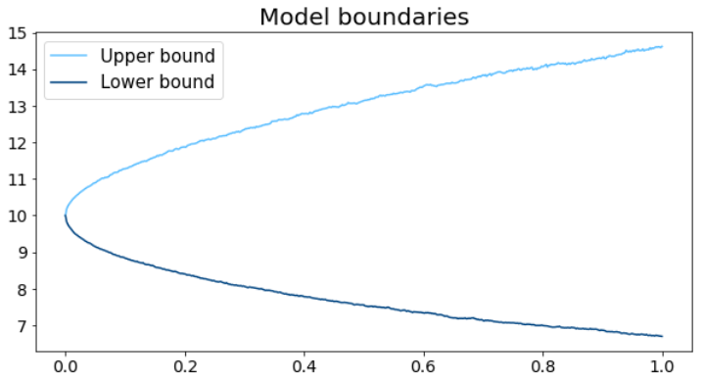

2.3. $τ$ Statistic Computation
To calculate the $τ$ statistic, let’s define an indicator:
$ψ_{ε}\left(t\right)=I\left(ε_{t}<L\left(t\right)\right)+I\left(ε_{t}>U\left(t\right)\right)$
This indicator is the number of times each scenario is outside the p-envelope. Then $τ$ is calculated as follows:
$τ_{ε}\left(T\right)=\frac{1}{T}\int_{T_{0}}^{T_{b}}{}ψ_{ε}\left(t\right)dt, T=T_{b}-T_{0}$
In other words, $τ_{ε}$ represents the fraction of time each path $ε$ spends outside the p-Envelope, within the backtesting interval $\left[T_{0},T_{b}\right]$.
Once the N $τ$ values have been calculated, the cumulative distribution function can be obtained:
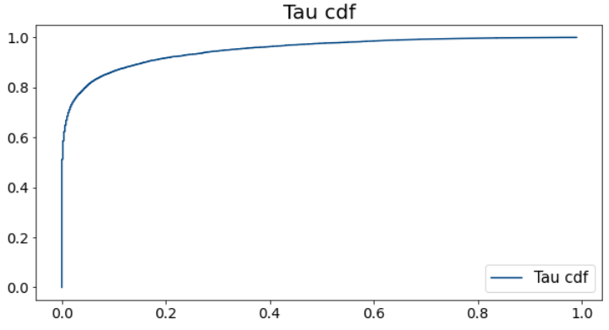

2.4. Color Bands
Depending on the results of our test, three color bands can be defined:
- Green band
- Yellow band
- Red band
Let’s set $p_{c}$ as the probability for the model to be good, and $p_{b}$ as the probability for the model to be bad. The color bands will be defined by the quantiles $D_{c}$ and $D_{b}$ corresponding to the probabilities $p_{c}$ and $1-p_{b}$.
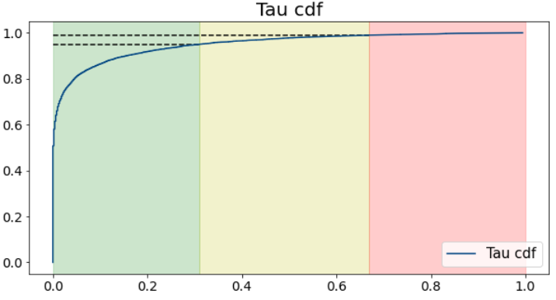
Once these bands are defined, $τ^{*}$ can be calculated for the real portfolio and check which band this $τ^{*}$ belongs to:
- If $τ^{*}≤D_{c}$, the model of exposure belongs to the green band and it can be accepted
- If $τ^{*}>D_{b}$, the model belongs to the red band, so the model should be rejected
- Otherwise, the model belongs to the yellow band, so it should be revised

Parameters Effect
In this section, the effect of the different parameters that affect directly to the results of this methodology is analyzed.
To be able to assess what is the probability of $τ^{*}$ belonging to one band or another, the following steps are followed:
- Simulate a large number of “realized” paths, $N^{*}$
- Then, for each of those “realized” paths, a $τ^{*}$ is obtained ($N^{*}$ values of $τ^{*}$)
- Finally, those values of $τ^{*}$ are mapped into the color bands

3.1. Time Steps Width
In this section it is assessed whether or not the width of the time steps is a determining factor. For doing so, a simple portfolio consisting of just one equity forward with no dividends is considered. This way, the price of this portfolio is not dependent on the volatility of the underlying.
To generate the realized paths, the test is repeated for a wide range of “realized” volatilities to check the effect of getting a very different volatility from the one used to calculate the envelope.
These are the parameters applied:
p-Envelope:
Forward: strike 10, maturity 1 year
Underlying: lognormal, spot 10, volatility 10%, r=1%
Bands: and

From higher to lower granularity:
- $delta=\frac{1}{250}=0.004→\#timesteps=250$
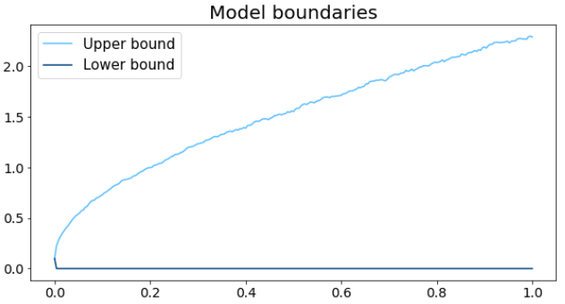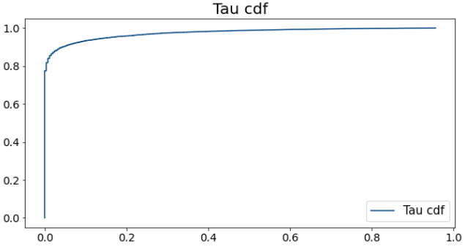
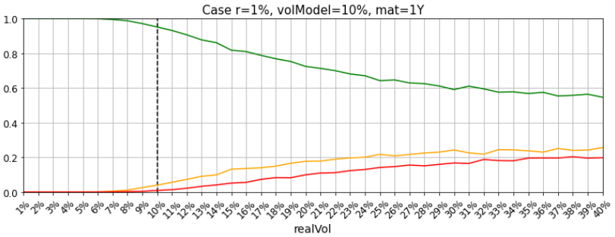
- $delta=\frac{10}{250}=0.04→\#timesteps=25$
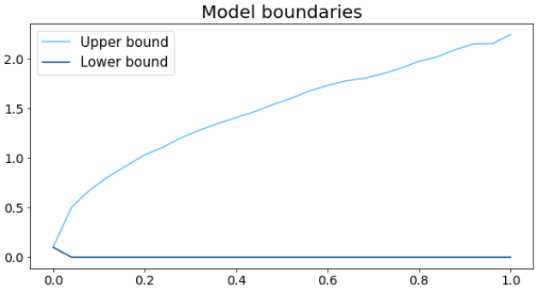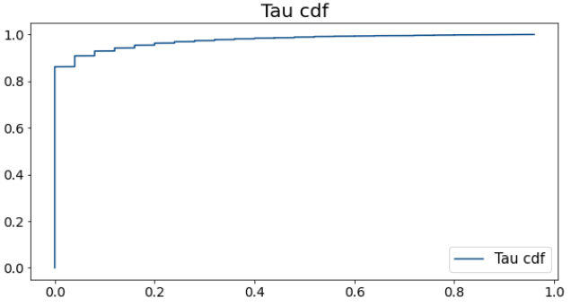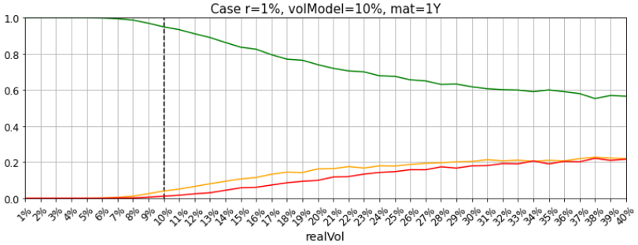

- $delta=\frac{20}{250}=0.08→\#timesteps=12$
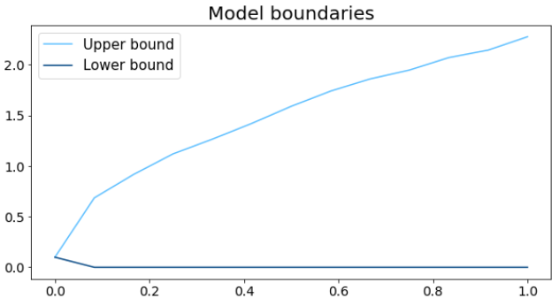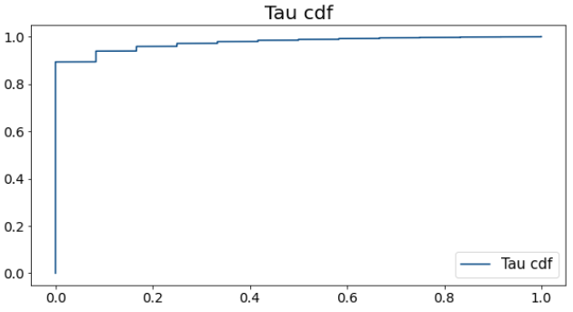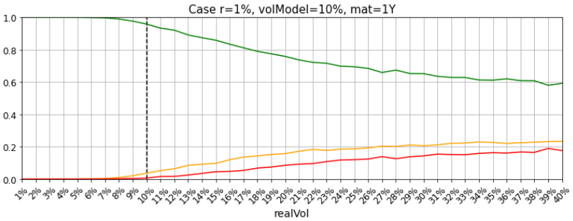
In the p-envelope and tau distribution graphics it can be seen that varying the width of the time steps only gives a difference in terms of discretization. But this does not affect the results of the methodology, as shown comparing the probabilities of belonging to each color band depending on different realized volatilities.
From now on, the rest of the tests are done using $delta=\frac{1}{250}$ so as to have more granularity.

3.2. Back Testing Time Horizon
It has been also checked what happens when changing the time horizon used for the backtesting ($T$).

- $T=6M→\#timesteps=125$
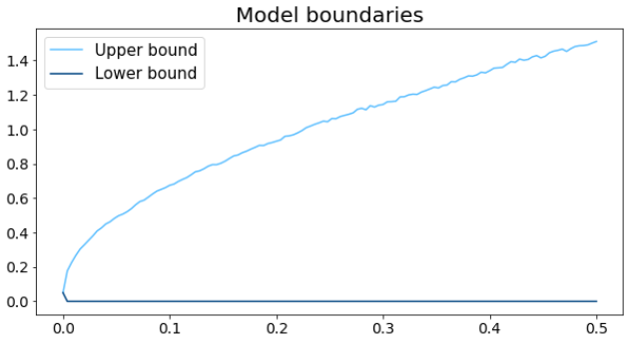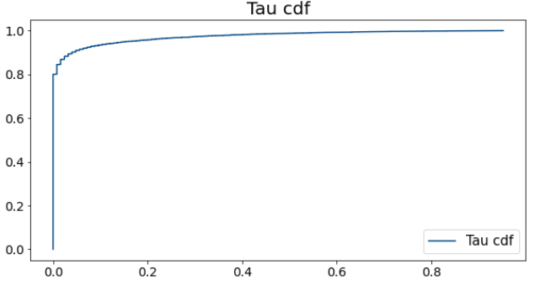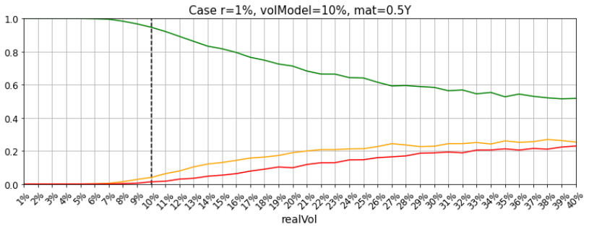
- $T=1→\#timesteps=250$
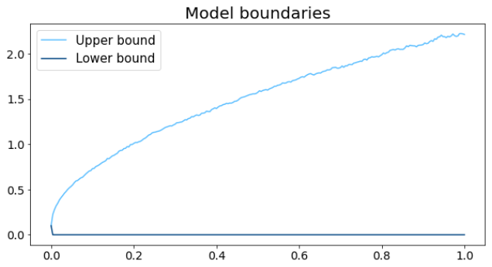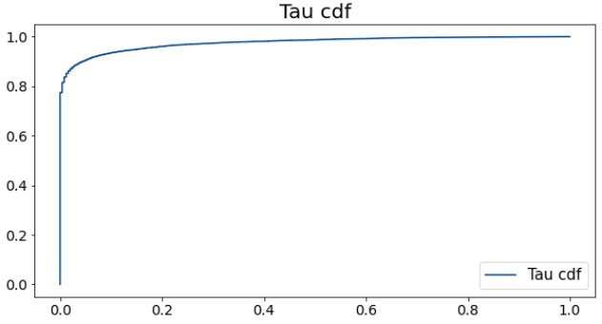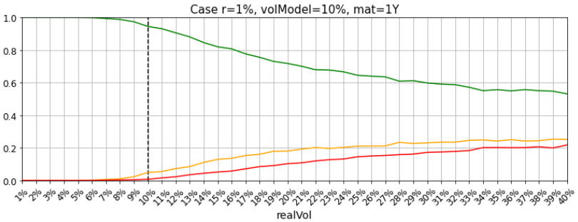
- $T=2→\#timesteps=500$
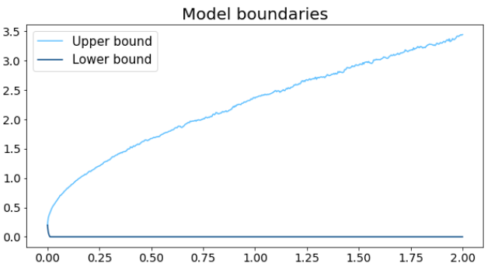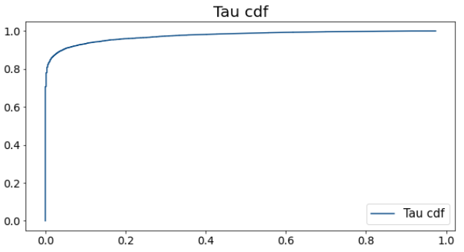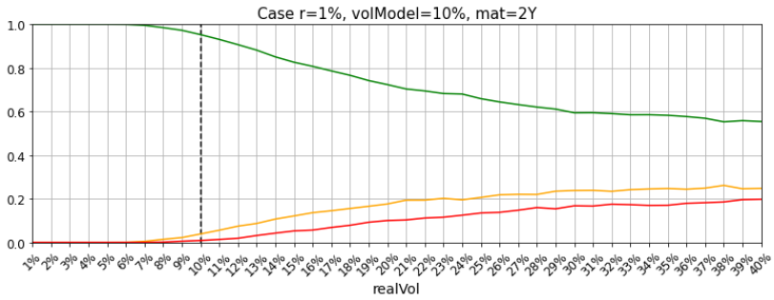
- $T=5→\#timesteps=1250$
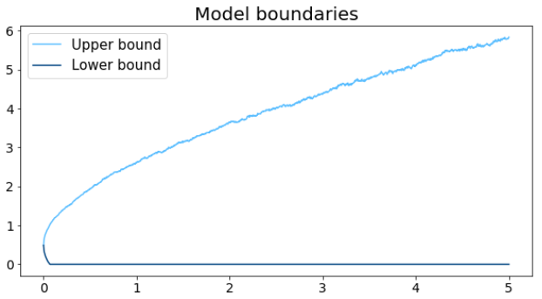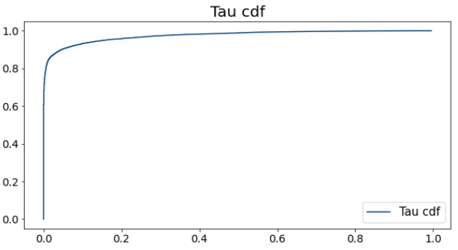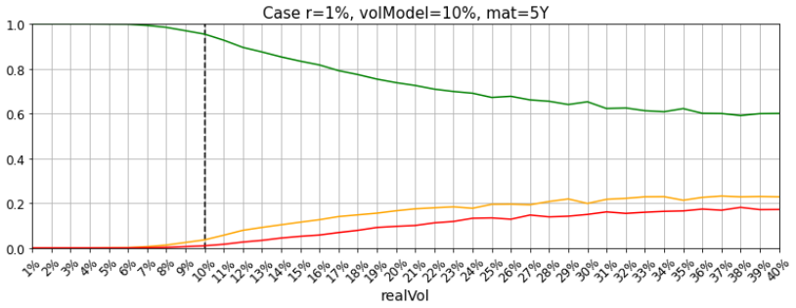
As happened when varying the width of the time steps, varying the backtesting time horizon does not affect the results of the methodology. The only difference that can be appreciated is that for realized volatilities really far from the model volatility, the probability of being in the green zone increases a little bit, unlike what happens with the probability of being in the red zone.

3.3. $p$ Parameter
In this section it is analyzed the effect of changing the $p$ parameter. The higher the $p$ (smaller the $α$), the wider the p-envelope becomes. This means that it is more difficult for the realized path to get out of the envelope, so there will be more tau values equal to zero, as shown in the graphics.
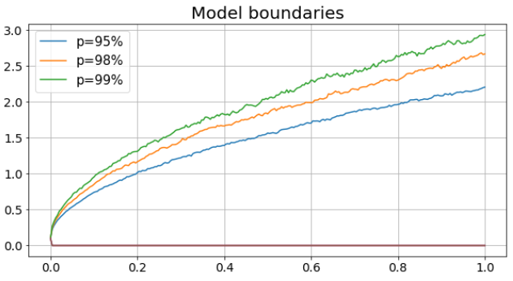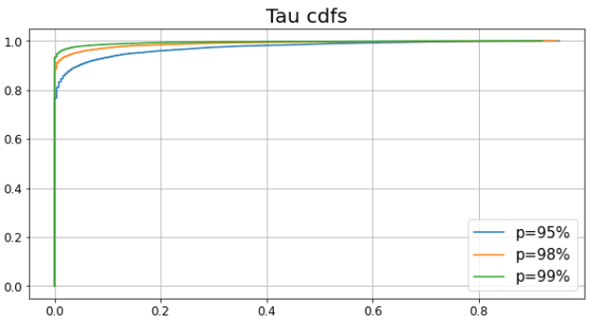
This results in the methodology becoming stricter as $p$ increases ($α$ decreses):
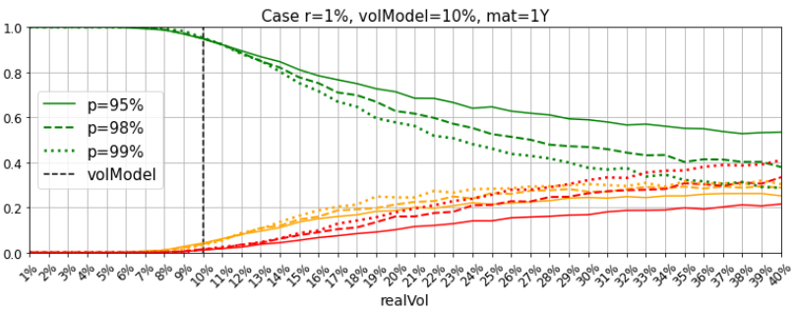

3.4. $p_{b}$ and $p_{c}$ Parameters
If we want to be stricter when deciding whether a model from the yellow zone must be in the red zone or not, a higher $p_{b}$ can be chosen, so that $1-p_{b}$ is lower and the probability of belonging to the red zone increases.
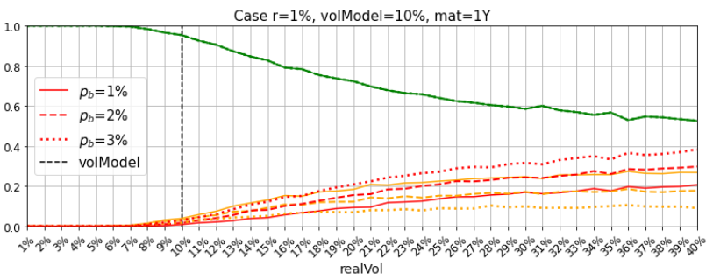
Exactly the same happens with the green zone and the use of $p_{c}$. For a higher $p_{c}$, there will be more paths mapped to the green zone and less for the yellow zone.
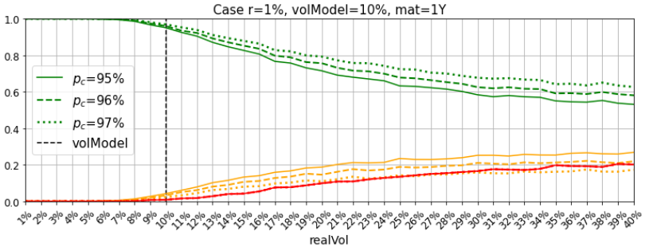

Backtesting with a Real Portfolio
Regarding exposures backtesting using a real portfolio, it requires a huge amount of resources to launch the test with a complete portfolio. As the regulation allows using a representative portfolio, this backtesting will be applied to a sub-portfolio meeting these criteria:
- It should contain at least the 8 counterparties with the greatest capital contribution, including only IMM trades.
- It should contain different counterparty credit risk mitigants: at least one uncollateralized counterparty, one fully collateralized and one with initial margin.
- The backtesting portfolio should be representative of actual portfolios accounting for at least 50% of the capital amount.
This portfolio should be reviewed once a year to ensure the compliance with these criteria.

Example Results
In this section we try to introduce the effect correlation between two underlying stocks and volatility have in the methodology.

3.2. Example 1: Two Forwards
An interesting test it is to see to what extent does the correlation between two underlying stocks affect the results previously obtained.
For this test, an equally weighted portfolio of two forwards has been used. These are the inputs:
p-Envelope:
Forward 1: strike 10, maturity 1 year, weight=50%
Underlying 1: lognormal, spot 10, volatility 10%, r=1%
Forward 2: strike 10, maturity 1 year, weight=50%
Underlying 2: lognormal, spot 10, volatility 10%, r=1%
Bands: and

Different correlations between the two underlying assets have been tested, and these are the results:
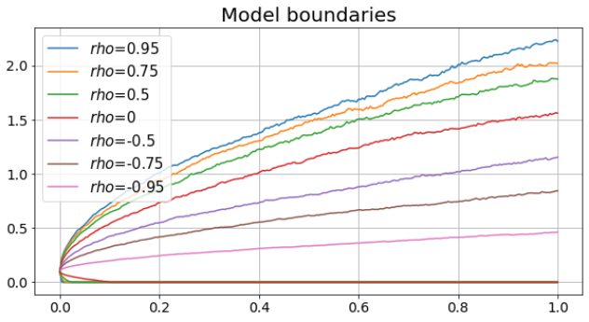
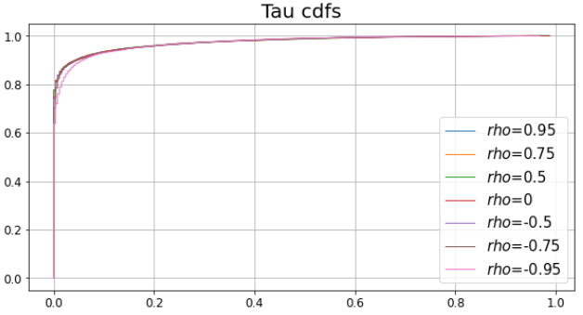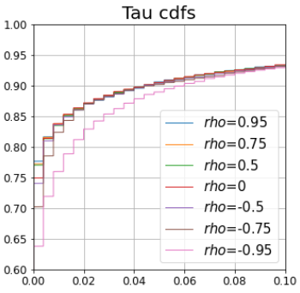

Zoom
The differences between positive correlations are small, but when correlation is lower, the p-envelope becomes narrower and the methodology becomes a little bit stricter.
Probability of being in the green zone: 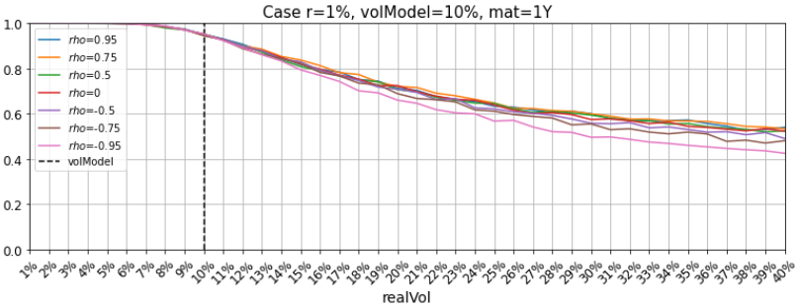
Probability of being in the yellow zone: 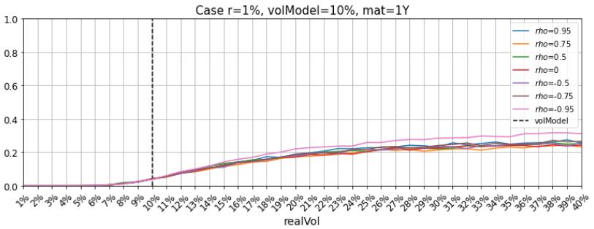
Probability of being in the red zone: 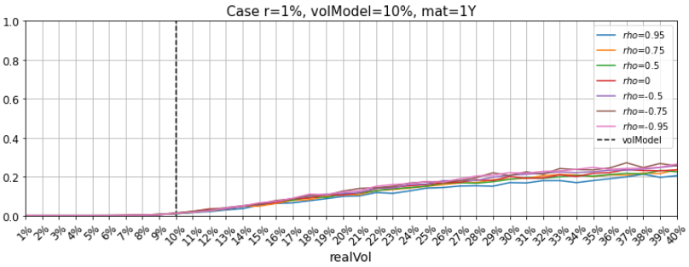

3.3. Example 2: A Call Option
In this example we introduce the volatility in the pricing of the portfolio. This time the portfolio used is one at-the-money call option:
p-Envelope:
Call: strike 10, maturity 1 year, weight=50%
Underlying: lognormal, spot 10, volatility 10%, r=1%
Bands: and

These are the results using this portfolio:
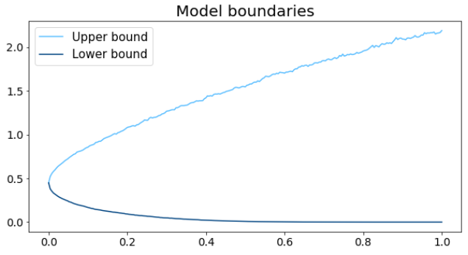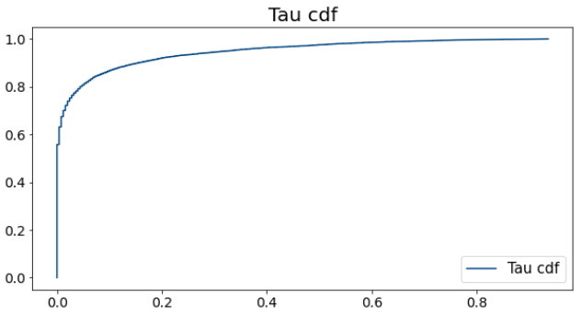
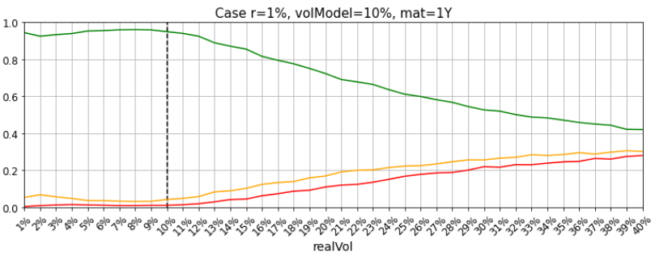
As can be seen, the p-envelope is narrower in the first time steps with a call than it was in the forward case. This increases the likelihood of the realized paths to get out of the envelope and their tau values are greater, which leads the methodology to be stricter.

3.4. Example 3: Two Call Options
As in the forward case, it has also been checked what happens if we apply the test with a portfolio of two ATM call options, to see how the correlation between the underlying assets affect.
This is the portfolio used:
p-Envelope:
Call 1: strike 10, maturity 1 year, weight=50%
Underlying 1: lognormal, spot 10, volatility 10%, r=1%
Call 2: strike 10, maturity 1 year, weight=50%
Underlying 2: lognormal, spot 10, volatility 10%, r=1%
Bands: and

And these are the results:
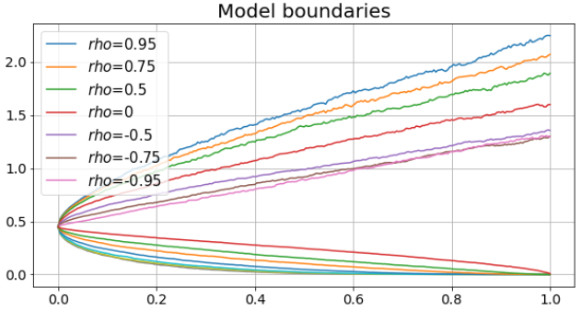
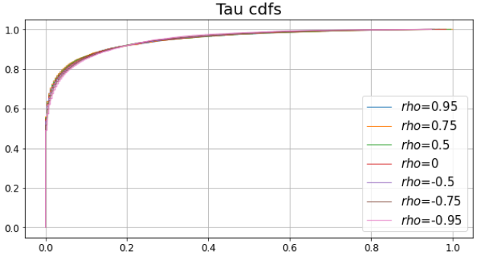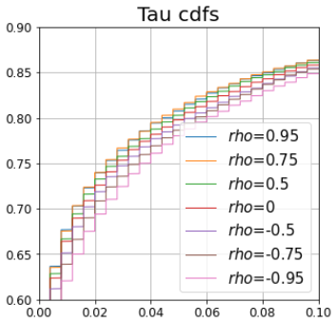

Zoom
As happens in the two forward case, tau values are greater as correlation lowers, which leads the methodology to be stricter. The results in this case (two calls) are even more pronounced.
It can also be seen that the results with two call options are pretty much stricter than the forwards case as realized volatilities move away from the volatility of the model.
Probability of being in the green zone: 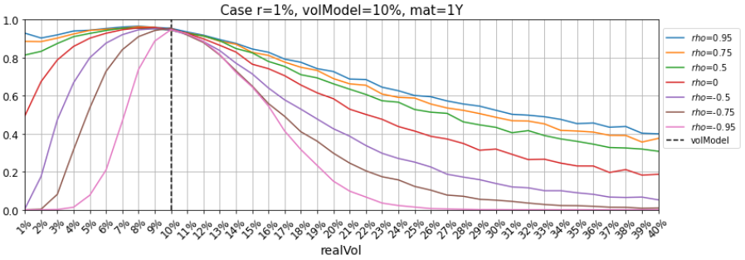
Probability of being in the yellow zone: 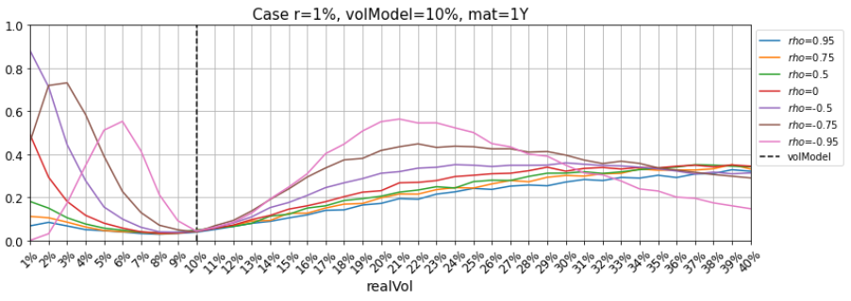
Probability of being in the red zone: 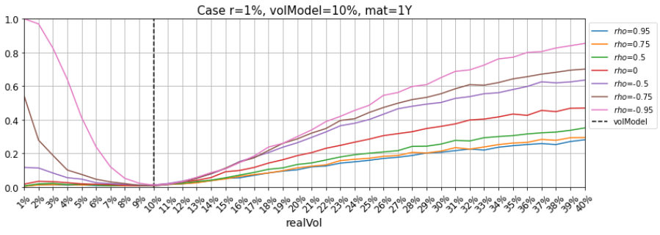

https://www.iruizconsulting.com/wp-content/uploads/2012/10/iRuiz_Backtesting_counterparty_risk_models1.pdf
Notice that 1-pb must be strictly greater than pc. In our examples, pb should be lower than 5%.

